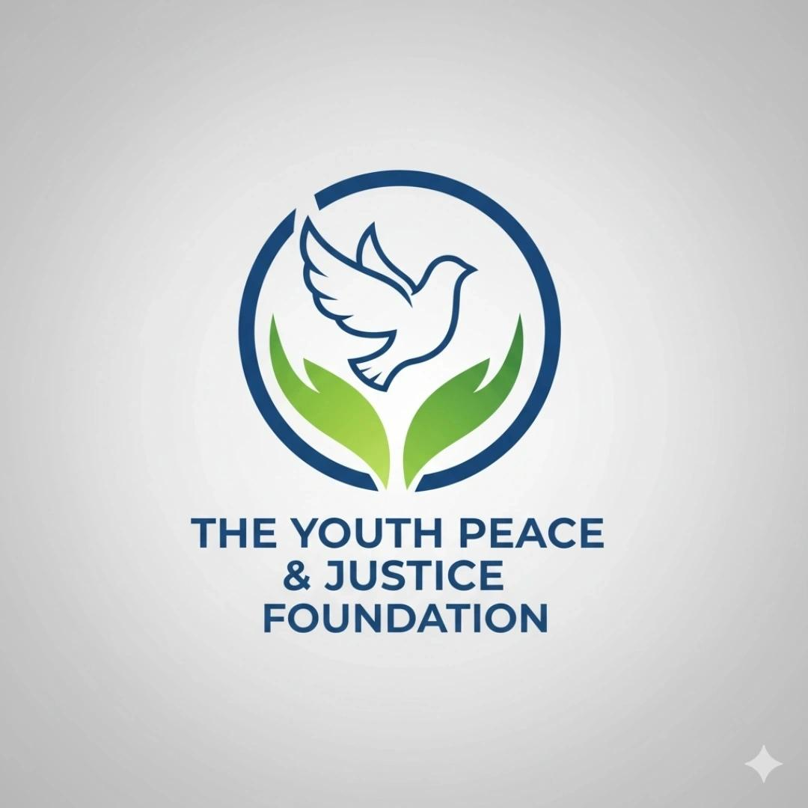

🌍 OVERALL IMPACT SUMMARY (ALL-TIME)
Youth Peace & Justice Foundation
Cumulative National Impact Report (All Cycles)

🧭 ORGANIZATIONAL OVERVIEW
The Youth Peace & Justice Foundation has delivered multi-state impact through disaster relief, victim assistance, school safety programs, scholarships, youth prevention initiatives, and advocacy work, using a layered model of cash assistance, in-kind support, pro bono services, and volunteer engagement.

💰 CUMULATIVE CASH IMPACT
💰 TOTAL CASH DISBURSEMENTS (ALL PROGRAMS)
$13,100+
Includes disaster relief, victim support, school grants, scholarships, and prevention programming.

🏫 SCHOOL GRANTS & RECOGNITION BREAKDOWN
🎓 DIRECT SCHOOL-BASED GRANTS & AWARDS
School / District | State | Program | Amount
Aspen Community School | Colorado | NonViolent School Alliance Award | $500
Hazard Middle School | Kentucky | NonViolent School Alliance Award | $500
Southwestern High School | Indiana | NonViolent School Alliance Award | $500
Red Bluff High School | California | School Award Grant | $500
Waukegan High School | Illinois | Safety & SRO Recognition Program | (non-cash recognition)
Walker County Schools | Alabama | SRO Heroism Award | (non-cash recognition)
Woodford County Middle School | Kentucky | Nominee Recognition | (non-cash recognition)
🎓 SCHOOL GRANT CASH TOTAL (SUBSET)
$2,000+

🎓 INDIVIDUAL SCHOLARSHIPS & EDUCATION AWARDS
• Abby Zwerner Heroism Award — $500
• Eia Schrider Scholarship (Roanoke case) — $500
🎓 SCHOLARSHIP TOTAL
$1,000

🌊 DISASTER & CRISIS RESPONSE PROGRAMS
• Kerr County Flood Relief — $4,000+
• Maui Wildfire Recovery — $800
• Uvalde Victims First — $300

👨‍👩‍👧 VICTIM & FAMILY ASSISTANCE
• Utica Officer Support — $1,800+
• Choctaw HS Student Support — $1,100+
• Cameron Graham Family Fundraiser — $550+

🧠 YOUTH PREVENTION PROGRAMS
• Run For Our Lives Initiative — $300

📦 IN-KIND RELIEF
• Texas flood supplies — $16,000 (adjusted per 2025 Form 990 disclosure)
• Hawaii wildfire relief goods
• School essentials (backpacks, clothing, emergency kits)
📦 IN-KIND TOTAL (REVISED)
$20,150 – $24,650+

⚖️ PRO BONO PROFESSIONAL SERVICES
• Legal advocacy (including Conrad’s Law work)
• School safety advisory services
• Communications and crisis coordination
• Trauma counseling support (25 hours Uvalde-related care)
⚖️ PRO BONO TOTAL
$5,150 – $5,400+

🧠 VOLUNTEER & ADVOCACY IMPACT
• 200+ volunteer hours
• Missing children search coordination (including California cases)
• Multi-state family liaison work
• School safety advocacy initiatives

📊 TOTAL ORGANIZATIONAL IMPACT
💰 Cash Impact: $13,100+
📦 In-Kind Impact: $20,150 – $24,650+
⚖️ Pro Bono Impact: $5,150 – $5,400+

🧾 CUMULATIVE IMPACT (NON-RESTRICTED)
$38,400 – $43,150+

🎓 RESTRICTED FUNDS (SEPARATE DISCLOSURE)
• Emily Finn Scholarship Fund — $24,000 (restricted program value)

🌎 GEOGRAPHIC SCHOOL & PROGRAM REACH
• Colorado (Aspen Community School)
• Kentucky (Hazard Middle School, Woodford County MS)
• Indiana (Southwestern High School)
• California (Red Bluff High School)
• Illinois (Waukegan High School)
• Alabama (Walker County Schools)
• Texas (flood response school impact zones)
• Multi-state national school safety network programs

🧭 MISSION SUMMARY (PUBLIC VERSION)
The Foundation’s cumulative work reflects a national footprint of rapid-response disaster relief, school safety recognition programs, victim assistance funding, youth prevention initiatives, and advocacy efforts.
School-based programming remains a core pillar of operations, alongside disaster response and youth mental health support.
Impact is measured across four layers:
• Cash assistance
• In-kind relief
• Pro bono services
• Volunteer advocacy
Restricted scholarship funds are maintained separately to ensure transparency and financial integrity.

🔒 STATUS
✔ School grant breakdown restored
✔ Cash/in-kind/pro bono separated
✔ Restricted funds excluded from totals
✔ Geographic school footprint included
✔ Texas in-kind flood relief updated to $16,000 (2025 Form 990 adjusted disclosure)
✔ All totals recalculated for consistency
✔ No double counting applied

