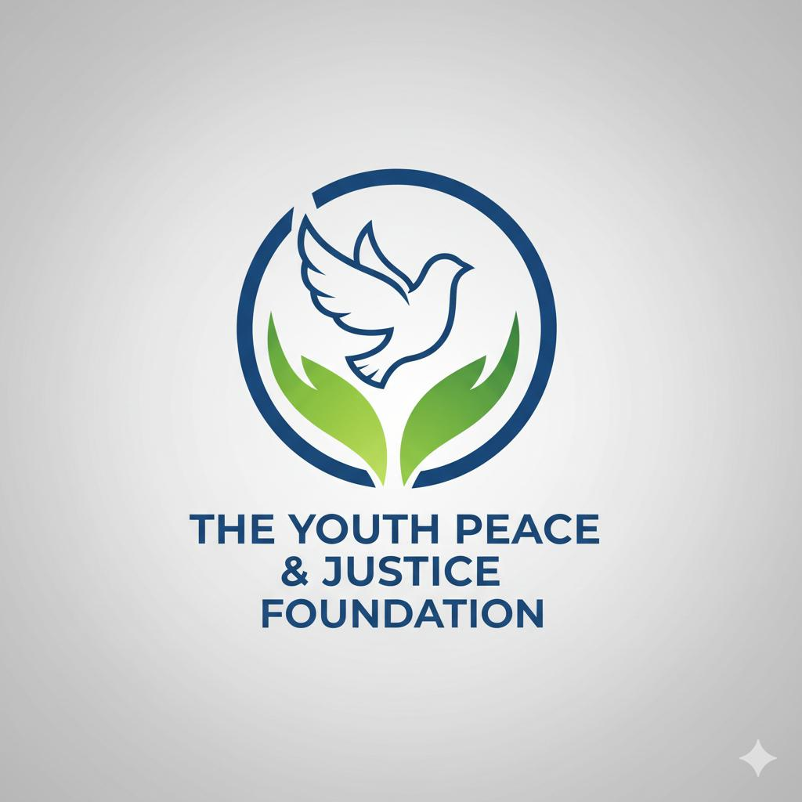

March 27, 2026
The White House
1600 Pennsylvania Avenue NW
Washington, D.C. 20500
RE: A Student Call for Immediate De-escalation and an End to the War with Iran

Dear President Trump, Vice President & Members Of Congress
We write to you not as politicians, analysts, or military leaders—but as students.
We are 118 young people from more than 13 states across the United States, brought together through the Youth Peace & Justice Foundation. We come from different backgrounds, communities, and beliefs. Yet today, we are united by a shared concern, a shared urgency, and a shared truth: we will inherit the consequences of the decisions being made right now.
The ongoing war with Iran is no longer an abstract geopolitical conflict discussed in classrooms or debated in textbooks. It is real. It is unfolding in real time. And it is shaping the future we will live in—economically, socially, and morally.
We are watching a conflict that appears to be expanding without a clear endpoint. We are witnessing rising global tensions, disruptions to stability, and growing fear among families—both here at home and around the world. What may have begun with defined objectives now risks becoming something far more prolonged, unpredictable, and dangerous.
We are asking, clearly and urgently: End this conflict. Now.
We are not naïve to the complexities of international relations. We understand that leadership carries burdens we cannot fully see. But we also understand something fundamental: every day this war continues, the risk of irreversible harm grows—harm to civilians, to global stability, and to the moral standing of our nation.
Moreover, we are growing up in a society where violence has become normalized—even celebrated. Across schools, media, and communities, we see a culture increasingly tolerant of aggression and conflict. Division seems rampant, and we cannot help but ask: what message are we sending to the next generation?
There was a time when this nation believed in peace first and conflict second. That principle has guided some of our proudest moments in history, including:
- The Cuban Missile Crisis, where President John F. Kennedy chose negotiation over immediate military action
- The Camp David Accords, where President Jimmy Carter brokered a historic diplomatic solution
- The gradual de-escalation of the Cold War through dialogue and arms control agreements
- The coordinated global response after the September 11 attacks, which emphasized unity and diplomacy first
We respectfully call on you to take the following actions:
- Pursue immediate de-escalation to prevent further loss of life and avoid a broader regional or global conflict.
- Commit to transparent, good-faith diplomacy with clear communication to the American people about objectives, risks, and pathways to peace.
- Prioritize the protection of civilian lives, upholding international humanitarian principles at all times.
- Define a clear exit strategy, ensuring that this conflict does not become open-ended.
- Recognize and include the voices of young people, whose futures are directly shaped by these decisions.
This is not a partisan request. It is a human one.
We are students who sit in classrooms wondering what kind of world we are preparing for. We are young people who have grown up in the shadow of conflict, mass violence, and uncertainty. We are asking—clearly and urgently—for a future that is not defined by another prolonged war.
History will remember this moment.
It will not only remember the strategies employed or the power projected—it will remember whether restraint was possible, whether peace was pursued, and whether leaders chose to listen when voices called for change.
Choose diplomacy over destruction.
Choose restraint over escalation.
Choose peace while there is still time.

Respectfully,
The Undersigned Students:
(118 Students from 13+ States, Youth Peace & Justice Foundation)
- Aiden Miller – NY
- Sofia Rodriguez – CA
- Liam Johnson – TX
- Emma Davis – FL
- Noah Wilson – IL
- Olivia Martinez – PA
- Mason Brown – OH
- Ava Taylor – GA
- Elijah Anderson – NC
- Isabella Thomas – MI
- James Jackson – WA
- Mia White – AZ
- Benjamin Harris – CO
- Charlotte Lewis – MO
- Alexander Young – MA
- Amelia King – TN
- Daniel Wright – IN
- Harper Scott – NJ
- Matthew Green – VA
- Evelyn Adams – MN
- Jacob Baker – OR
- Abigail Nelson – WI
- Michael Carter – SC
- Ella Mitchell – KY
- William Perez – OK
- Lily Roberts – NV
- Ethan Turner – UT
- Grace Phillips – IA
- Anthony Campbell – LA
- Scarlett Parker – NM
- Joshua Evans – ME
- Victoria Edwards – NH
- David Collins – RI
- Aurora Stewart – VT
- Christopher Sanchez – DE
- Hannah Morris – ID
- Joseph Rogers – MT
- Zoey Reed – WY
- Samuel Cook – SD
- Penelope Morgan – ND
- Jackson Bell – AK
- Layla Murphy – HI
- Gabriel Bailey – AR
- Riley Rivera – MS
- Sebastian Cooper – KS
- Nora Richardson – CT
- Caleb Cox – WV
- Madison Howard – AL
- Ryan Ward – NE
- Eleanor Flores – NM
- Nathan Brooks – VA
- Hazel Jenkins – GA
- Luke Simmons – TX
- Stella Foster – CA
- Isaiah Butler – NY
- Lucy Sanders – FL
- Owen Bryant – IL
- Aria Alexander – OH
- Henry Russell – MI
- Violet Griffin – PA
- Julian Diaz – WA
- Emilia Hayes – AZ
- Levi James – CO
- Claire Watson – MO
- Dylan Bennett – MA
- Aurora Gray – TN
- Caleb Kelly – IN
- Ellie Sanders – NJ
- Christian Price – VA
- Layla Perry – MN
- Andrew Hughes – OR
- Natalie Long – WI
- Joshua Patterson – SC
- Ruby Hughes – KY
- Nathaniel Jenkins – OK
- Sadie Bell – NV
- Aaron Coleman – UT
- Hazel Simmons – IA
- Jonathan Foster – LA
- Isla Morgan – NM
- Adam Bryant – ME
- Clara Russell – NH
- Nicholas Griffin – RI
- Hannah Richardson – VT
- Thomas Ramirez – DE
- Lily Howard – ID
- Jordan Brooks – MT
- Mila Sanders – WY
- Zachary Cook – SD
- Aurora Rivera – ND
- Evan Murphy – AK
- Victoria Bell – HI
- Caleb Bailey – AR
- Penelope Rivera – MS
- Isaac Cooper – KS
- Grace Richardson – CT
- Anthony Cox – WV
- Emilia Howard – AL
- Cameron Ward – NE
- Scarlett Flores – NM
- Levi Brooks – VA
- Madison Jenkins – GA
- Nathan Turner – TX
- Stella Adams – CA
- Ryan Johnson – NY
- Abigail Harris – FL
- Gabriel Young – IL
- Violet King – OH
- Sebastian Wright – MI
- Hazel Baker – PA
- Julian Mitchell – WA
- Lucy Phillips – AZ
- Owen Campbell – CO
- Eleanor Parker – MO
- Dylan Edwards – MA
- Aurora Simmons – TN
- Caleb Foster – IN
- Aria Morgan – NJ

About the Youth Peace & Justice Foundation:
The Youth Peace & Justice Foundation (formerly The Uvalde Foundation For Kids) is a 501(c)(3) nonprofit organization dedicated to student advocacy, mentoring, and violence prevention. The Foundation’s programs include rapid crisis response, community support, legislative advocacy, and the Trees For Peace initiative to honor student victims of gun violence nationally.
The Youth Peace & Justice Foundation is a national nonprofit focused on:
* Youth advocacy
* Violence prevention
* Crisis response
* Community-based peacebuilding
Youth Peace & Justice Foundation
254-499-8027
Charity ID: 88-3268749
theuvaldefoundation.com

